Indian Job Market Analysis Dashboard

**1. Project Overview**

The Indian Job Market Analysis Dashboard aims to provide a comprehensive overview of current employment trends across various industries and locations in India. It helps identify high-demand roles, popular job locations, emerging skill requirements, and salary patterns.

— empowering recruiters, job seekers, and analysts with data-driven insights.

**2.Data Summary**

- Rows: 20000

- Columns: 20

- Key Features:

- Job Information (job_id , job_title , experience_required , experience_level, education_requirement)

- Company Information (company_name, company, Size)

- Location & Work Mode (job_location, Remote_Onsite)

- Salary & Applicants (Salary_range , number_of_applicants)

- Skills & Requirements(skills_required, education_requirement)

- Job Posting Timeline(posted_date, application_deadline, job_portal)

**3. Exploratory Data Analysis using Python**

We began with data preparation and cleaning in Python:

* **Data Loading:** Imported the dataset using **pandas** for data manipulation and analysis.
* ● **Initial Exploration:** Used **.info()** to check data types and structure, and . **describe**() for summary statistics.

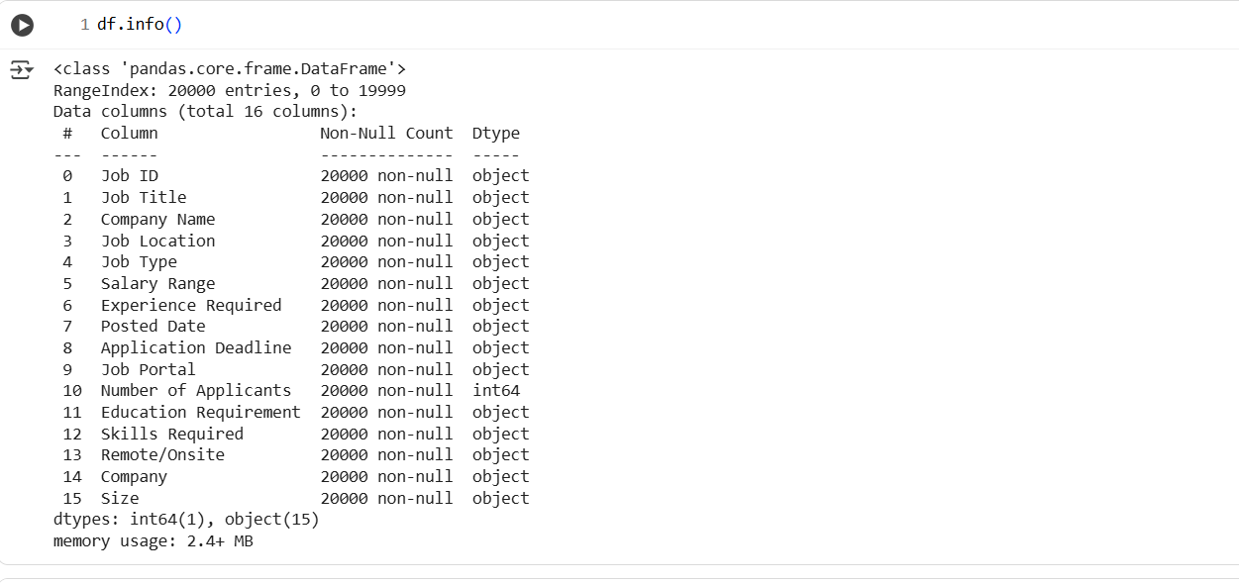

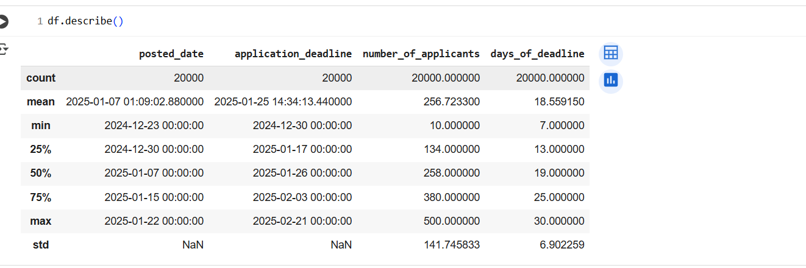

**Missing Data Check**: Executed **df.isnull().sum()** — result showed **zero missing** **values** across all columns, ensuring data completeness**.**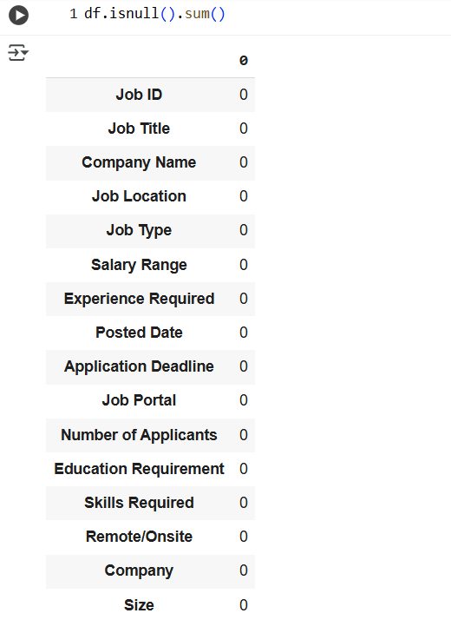

● **Column Standardization:** Renamed all columns to **snake_case** format for better readability and consistent documentation.

● **Feature Engineering:**  
○ Created derived columns such as **job_level** (based on experience) **Application_deadline**

● **Data Consistency Check:** Verified categorical columns such as **job_type**, **remote/onsite**, and **company_size** for uniform formatting.

**4. Data Analysis using SQL (Job Market Data set)**

**1.City vs remote job opportunities :** Identify Top 5 cities offering the most remote job listings.

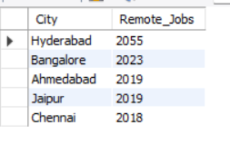

**2. across all companies vs most in-demand job titles:** Determine which job roles are most frequently posted by the Companies.

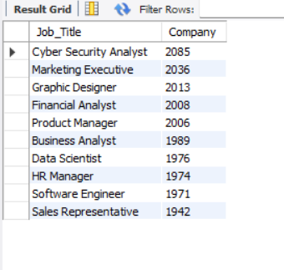

**3.Company VS Highest number of Full-time jobs**: Analyze hiring patterns among companies.

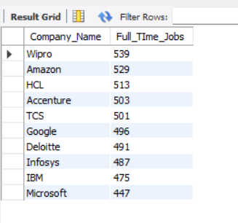

**4. Average number of applicants for Jobs offering more than 10 LPA:** Understand candidate interest in high-paying jobs.

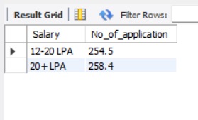

**5. Education Qualification Is Most Commonly Required By Companies:** Identify the most preferred educational level across roles.

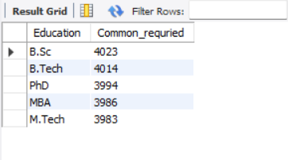

**6. Job Portals (Linkedin, Naukri, Indeed) Have The Most Listings:** Evaluate which platform has the highest job visibility.

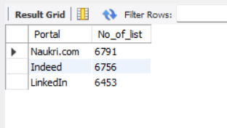

**7. Companies Are Offering Remote Jobs With Salaries Above 15 LPA:** Identify high-paying remote opportunities and their providers.

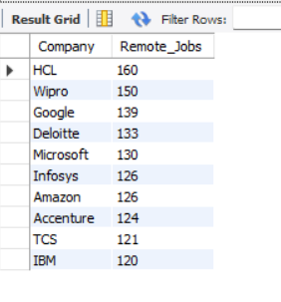

**8. Experience Level Vs Average Salary Range:** Compare salary expectations and applicant competition across experience levels.

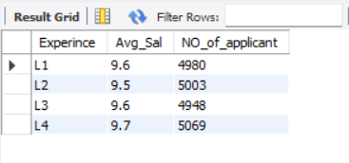

**9. Locations Have The Most Hybrid Job Opportunities For Technical Roles (E.G., Software Engineer, Data Analyst):** Find the best cities offering flexibility for technical professionals.

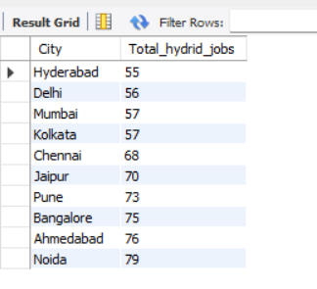

**5. Dashboard in Power BI**

Finally, we built an interactive dashboard in **Power BI** to present insights visually.

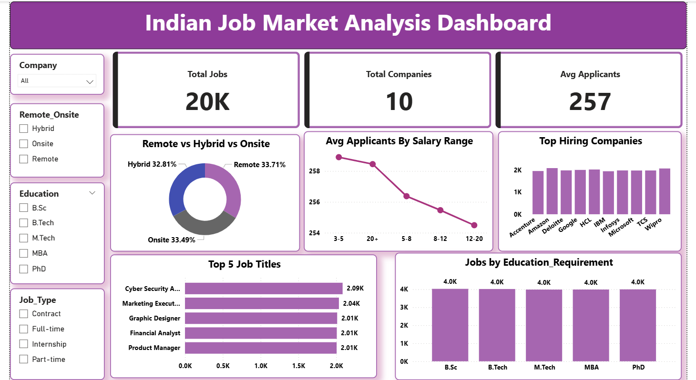

**6. Business Recommendations**

**Business Recommendations (Simplified)**

* Encourage **remote and hybrid jobs** to attract more candidates.
* Focus hiring on **top in-demand roles** like Cyber Security Analyst, Marketing Executive, and Product Manager.
* Review **salary ranges** — offer competitive pay to balance applicants and job quality.
* Strengthen **employer branding** for startups to compete with big companies.
* Hire from **diverse education backgrounds** (B.Sc, B.Tech, MBA, etc.).
* Use **multiple job portals** (LinkedIn, Naukri, Indeed) to reach a wider audience.
* Prioritize **skill-based hiring** instead of only qualifications.
* Expand **remote hiring** to reduce costs and reach talent in more locations.
* Offer **career growth and training programs** to retain skilled employees.
* Continuously **analyze market trends** to update hiring strategies.